<https://www.youtube.com/watch?v=1TSJl0dMAB0&list=PLJG0ckVr6qSDaqCwYO1VKnJkQgFTwu9zk&index=1>

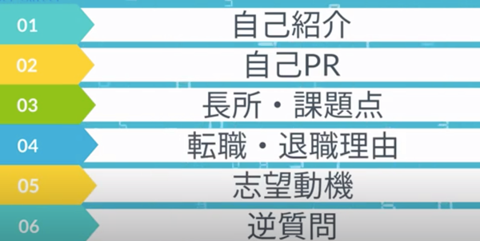





















































































https://www.youtube.com/watch?v=oCQ2Ge8AAYM&list=PLJG0ckVr6qSDaqCwYO1VKnJkQgFTwu9zk&index=2

